Health Data Research UK

Applicant Pack

Job description and person specification
Post: Technical Project Manager and Agile Scrum Master for the International COVID-19 Data Alliance
Location: HDR UK Offices, Health Data Research UK, Gibbs Building, 215 Euston Road, London, NW1 2BE
Salary: £64,515
Reporting to: Technical Director, International COVID-19 Data Alliance
Contract: FTC until 01 June 2021 with potential for extension subject to funding.

About Health Data Research UK
Health Data Research UK (HDR UK) is the national Institute for data science in health. Our UK team of experts develop and apply cutting-edge data science approaches to clinical, biological, genomic and other multi-dimensional health data to address the most pressing health research challenges facing the public.
Our mission is to make game-changing improvements in the health of patients and populations through data science research and innovation.
We have been central to the UK’s response to COVID-19, enabling a trustworthy, national approach to using health data, drawing on the full capabilities of UK research. This has helped with understanding the virus, clinical trials for treatments (including Dexamethasone), symptom trackers, risk calculators and impacts on vulnerable groups, including cancer patients.
By undertaking research at scale, across a population of up to 65 million people, we have an unrivalled opportunity to use data to the highest ethical standards to drive breakthroughs in medical research. This unleashes the potential to improve the way we are able to prevent, detect and diagnose diseases such as cancer, heart disease and asthma.
We are bringing together our unique nationwide health data assets and specialists across academia, research and healthcare to unlock knowledge and deliver new insights from molecule to man. This is being achieved through a three-part health data research infrastructure – the Alliance, Hubs and Gateway:

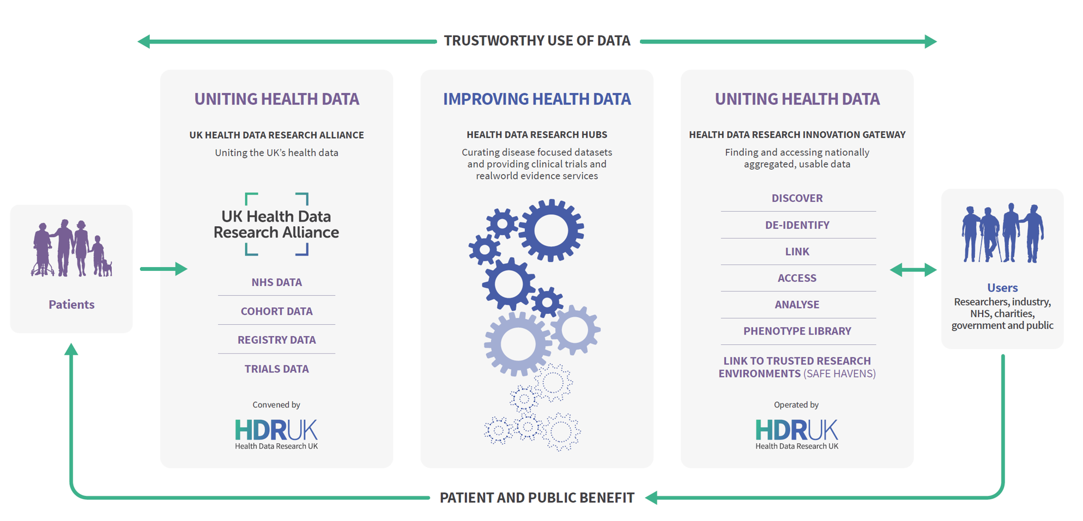

Find out more about the Alliance, Hubs and Innovation Gateway.

At Health Data Research UK we employ talented individuals who bring their own unique skills and experience to support the vision and benefit the whole team.

About the International COVID-19 Data Alliance (ICODA)
ICODA is a high profile, charity-funded, international collaboration which will create an International Alliance of data custodians and provide a digital workbench for researchers and innovators to impact our COVID-19 response by enabling the sharing of data at scale.

Announced on 26 June 2020, ICODA is an independent consortium of leading life science, philanthropic and research organisations uniting to respond to the COVID-19 global pandemic. The aim is to transform the way that scientists and researchers access health data from clinical trials, biomedical and health research studies to answer the most pressing health-related questions about COVID-19. It is particularly focused on ensuring inclusion from researchers from lower- and middle-income countries (LMIC).

The Workbench will provide a trustworthy platform to access data for collaborative data science. It will have several key functions:
- Allow researchers to search and find relevant data from multiple repositories across the world.
- Allow researchers to request access to data from multiple sources to address specific research questions.
- Allow data custodians to retain control of decisions about how data they hold can be accessed and used.
- Allow researchers to form virtual teams to address specific questions or projects in private, secure workspaces provisioned to meet the requirements of their projects.
ICODA will facilitate access to data from multiple sources through a trustworthy data infrastructure, with robust governance and stewardship to enable a rapid response to COVID-19 and future disease outbreaks.
These are important because they are addressing an urgent, unmet need to access global health data at scale for research and innovation to rapidly understand the disease and how to prevent and treat it.
More information is available at www.icoda-research.org.

Purpose of the post
HDR UK requires the services of an experienced Technical Project Manager and Agile Scrum Master to support ICODA. They will combine management and planning of the delivery of all technical aspects of the programme of activities employing an Agile approach. They will be responsible for smooth running of the technical projects, working across multiple technical partners, acting as scrum master for each technical project. This will require a start-up mindset, working hands on with the rest of the team to put in place initiative-wide processes and procedures and rollout of technical tooling and usage. The individual will be responsible for technical delivery and provide technical delivery oversight of the Workstreams (including Technology, Workbench DevOps & Service Delivery; Data Standards & Curation; Data Science Enablement).
The Technical Project Manager will report to ICODA’s Technical Director.
This role will learn from and build upon the work of HDR UK.

Main Responsibilities:
Project Management
- Providing Technical Project Management across ICODA and business partner teams to successfully deliver the technical projects needed to deliver on ICODA’s goals.
- Creating and maintaining a technical roadmap and sprint plan with ICODA’s technology partners and ICODA leadership.
- Proactively managing progress versus that roadmap and plan.
- Identifying and working with the teams to address delivery issues and ensure corrective action is in place, with escalation to Technical Director when required
- Proactively managing technical risks across the project, ensuring risk status is updated and mitigation actions are identified and in place working with the PMO.
- Driving key technical and architectural decisions to conclusion.
- Providing support to other project managers working within the initiative and our partners.

Agile Scrum Master
- Performing the Scrum Master role across multiple technical teams and technology partnerships.
- Organizing key Scrums, ensuring actions are tracked and acted on, tracking progress against targets.
- Provide ad-hoc Agile and Scrum education to team members and partners as needed as the focal point for Agile in the organisation.

- Maintaining a high level of knowledge of the entire technical architecture, its constituent parts and partnerships, risks and interdependencies in order to be able to advise Driver Project Leads, Project Managers and the Executive Leadership Team.
- Supporting colleagues to create relevant technical presentation materials to support discussion and decision making at Leadership Team meetings and meetings with Funders and other key stakeholders
- Providing expertise, advice and technical implementation skills for systems implementation and setup across multiple teams
Planning and Organising:
- Facilitating the development and regular updating of an integrated project plan to ensure overall initiative and Driver Project(s) deliver the roadmap.
- Lead as Scrum Master delivering technical projects across Workstreams
- Tracking of and reporting on all aspects of project management cycle including progress, budget, milestones etc. to key internal/external stakeholders
- Creating processes and systems to enable efficient working and process improvement, including working with others to develop tracking systems.

Problem Solving:
The post-holder will be expected to use problem solving skills to respond to diverse demands. As part of a small team, the post holder will operate with significant autonomy and will require confidence and resilience in planning and in dealing with enquiries and challenges that arise across the ICODA work programme, requiring a flexible approach, problem solving and decision-making skills. The post holder will make an effective judgement on when to escalate issues to senior colleagues’ attention and with what urgency.

- Identifying and leading the resolution of problems associated with the ICODA Gateway, Workbench, Databanks and other key technologies involved in the International Alliance.
- Identifying ways to successfully communicate technical information to and from business partners.
- Providing specialist technical leadership, governance advice and input to ICODA project Workstreams

Decision making:

- The post-holder will make all day-to-day operational decisions for their own workload
- Technical project decisions necessary in daily scrums to advance progress of all technical partner projects
- Technical project recommendations across ICODA.
- Determining whether technical projects are conforming to HDR UK architectural principles and best practices.
- Driving synergistic decisions between the International Alliance and HDR UK building blocks and architecture to promote re-use and sharing
- Identifying issues or problems which may jeopardise project deadlines or compromise the outcome required and highlighting these to the executive team.

Continuous Improvement:

HDR UK is dedicated to continuous improvement through our quality management system and demonstrated by our commitment to achieve ISO 9001 accreditation. The post-holder will review, analyse, identify and implement opportunities for quality improvement within their specialism and as part of the wider team through our strategy development and internal audit processes.

Key contacts / relationships:
Work collaboratively and closely with staff from across the International Alliance, HDR UK, technical and business partners who are involved in ICODA and HDR UK data management, software development, and data analysis.
Supporting ICODA’s Technical Director, ensuring ICODA requirements are met, including both operational and support aspects by the ICODA team itself and its technical partners.
Provide Agile project leadership across ICODA and broader team as the Agile expert and Scrum master.

Knowledge, skills and experience
Essential:
- At least 3 years of proven experience managing technical projects
- Ability to analyse complex scenarios, distil key points and take pragmatic action to move projects forwards in an agile manner.
- Proactive and supportive approach to engagement with colleagues to support problem solving with ability to determine when issues need to be escalated.
- At least 3 years of proven technical scrum management experience across complex multi-national and multi-stakeholder projects.
- Experienced as a Scrum Master in an Agile development environment.
- Ability to setup and drive Agile scrum tooling to support projects
- High quality and concise communication skills, written and verbal.
- An ability to act at pace with a high degree of accuracy and independence, across international time zones.
- Ability to work in self driven fashion in a dynamic, fast-moving international environment establishing structures and processes, clear information flow and ensuring effective stakeholder engagement.
- Ability to see the big strategic picture in combination with flexibility to operate at a tactical, hands-on level.
- Alignment to the HDR UK values.

Desirable:
- Experience working with health data and health organisations and an understanding of Information Governance requirements, data curation and data standards for health data.
- Experience using Confluence, JIRA, Trello and similar Agile project management tools.
- Experience of Information Governance processes and requirements.
- An understanding of research delivery within the public sector, academia and/or industry.

Dimensions

- This will be a 5 day per week role FTC until 01 June 2021 with potential for extension subject to funding.

- All HDR UK roles are primarily based at our London offices, however we are flexibly working across a number of geographical locations. All our teams are currently working remotely, and we will make flexible office working available again once restrictions are lifted.

Application Process

Please apply with a CV and covering letter of no more than 500 words explaining what you can bring to this role, including your current salary, to hdruk@gravitatehr.co.uk.

The closing date for this vacancy is 5pm on Monday 8 March.

Interviews are expected to take place on week commencing 15 March.

HDR UK’s values
HDR UK’s values guide how we work together within HDR UK and with our partners and other stakeholders:
- Transparency: we will share information, insights and innovations so that we learn faster together.
- Optimism: we believe that we can make things better, that we can do things differently and that we can overcome challenges to create a new and thriving health data ecosystem that benefits patients and the public, the NHS, scientific discovery and industry.
- Respect: we deliver better results when we work in a truly interdisciplinary way. We listen, share and respect a diversity of thought and opinion, perspective and experience. We are inclusive - leveraging and fairly attributing the expertise and capabilities of others.
- Courage: we are leading the way and will be prepared to try new things, take risks, embrace ambiguity and challenge the status quo. We will contribute opinions to shape the future of health data research.
- Humility: we have a lot to learn from others; and aim to be free from pride and arrogance.

Equal Opportunities Policy Statement
Health Data Research UK is an equal opportunities employer, and as such aims to treat all employees, consultants and applicants fairly. It is our policy to provide employment equality to all, irrespective of:
- Gender, including gender reassignment
- Marital or civil partnership status
- Having or not having dependants
- Religion or belief
- Race (including colour, nationality, ethnic or national origins)
- Disability
- Sexual orientation
- Age

We are opposed to all forms of unlawful and unfair discrimination. All job applicants and employees who work for us will be treated fairly and will not be unfairly discriminated against on any of the above grounds. Decisions about recruitment and selection, promotion, training or any other benefit will be made objectively and without unlawful discrimination. Our diversity and inclusion policy is here.

